**Lesson Twenty: The Last Week of the Life of Jesus – II**

**Jesus’ Last Public Discourse. Denunciation of the Scribes and Pharisees (Matt. 23:1-39; Mark 12:38-40; Luke 20:45-47)**

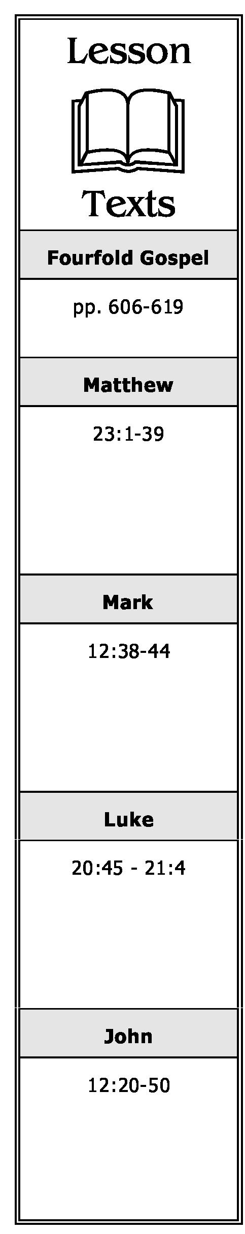

1. What did Jesus tell His disciples to do in relation to the teachings and commands of the scribes and Pharisees? Why?

2. What did the scribes and Pharisees do in relation to their own teachings and commands? Why?

3. What motivation did the scribes and Pharisees have for doing the works they did? What were some of the things they did? What did Jesus say would be their “reward” for doing them?

4. What did Jesus teach in regard to the following titles?

1. Rabbi.
2. Father.
3. Teacher.

5. Who is greatest among those who would serve God? Explain.

6. What will happen to one who “humbles himself”? To one who “exalts himself”? Explain.

7. How could the scribes and Pharisees “shut up the kingdom of heaven”?

8. How, according to verses 14 and 15, were the scribes and Pharisees hypocrites?

9. How were the scribes and Pharisees “blind guides”? What was wrong with their teachings concerning “swearing”?

**A Chronological Study of the Life of Jesus Gene Taylor** 53

1. Were the scribes and Pharisees condemned for tithing “mint and anise and cummin”? Explain.
2. What were the “weightier matters of the law”? How had the scribes and Pharisees neglected them?
3. How did the scribes and Pharisees “strain out a gnat and swallow a camel”?
4. How were the scribes and Pharisees like dishes that were clean on the outside but dirty on the inside?
5. How were the scribes and Pharisees like “whitewashed tombs” (KJV: “whited sepulchres”)?
6. How were the scribes and Pharisees hypocrites in regard to the “prophets”?
7. What was Jesus’ desire concerning Jerusalem? Why could it not be fulfilled? What was going to happen to Jerusalem instead?

**Observing the Offerings and Widow’s Mites (Mark 12:41-44; Luke 21:1-4)**

1. Why did Jesus say the widow who put two mites into the treasury had put in more than others who had “put in much”?

**Greeks Seek Jesus. He Foretells that He Shall Draw All Men Unto Him (John 12:20-50)**

1. What did certain Greeks ask of Philip? What did he do? What was Jesus’ response to their request?
2. What did Jesus say must happen to a grain of wheat before it can bring forth fruit? What application did He make of this teaching?
3. Where did Jesus say His servants would be? What makes that possible?
4. Why was Jesus’ soul “troubled”? For what purpose had He come to this “hour”?
5. What request did Jesus make of the Father? What response was given?

**A Chronological Study of the Life of Jesus Gene Taylor 54**

1. What did the people make of the above response? What explanation did Jesus give of it?
2. Who is the “ruler of this world”? How would he be “cast out”?
3. What was Jesus referring to when He said, “if I am lifted up from the earth”? Explain.
4. How would “all peoples” be drawn to Jesus?
5. Why did the people ask Jesus to identify “the Son of Man”? What was His response?
6. How could the people become “sons of light”?
7. Did the people, as a whole, believe in Jesus? What prophecies were fulfilled by them in that regard?
8. Why did the rulers who believed in Jesus not confess their belief?
9. What reason did Jesus give for coming in the world?
10. What will judge people in the last day? Why is that such an appropriate standard of judgment?

**A Chronological Study of the Life of Jesus Gene Taylor** 55